**Create User Screen**

1. Add a new blank screen

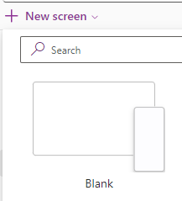

1. Rename the screen to UserScreen

1. Create a new container

1. Rename it to UserHeaderCont

1. Insert a new header

1. Rename it to LoginHeader

1. Put it under UserHeaderCont

1. Add a new back arrow icon

1. Rename it to UserBackIcon

1. Go to the Title component of UserHeader

1. Change its value to “User Screen”

1. Adjust UI.

